
ОБЩЕСТВО С ОГРАНИЧЕННОЙ ОТВЕТСТВЕННОСТЬЮ
«ЛАЗЕРТАГ»

ПАСПОРТ

Смоленск
LIMITED LIABILITY COMPANY
LASERWAR

GAME SET
"Wild West" target

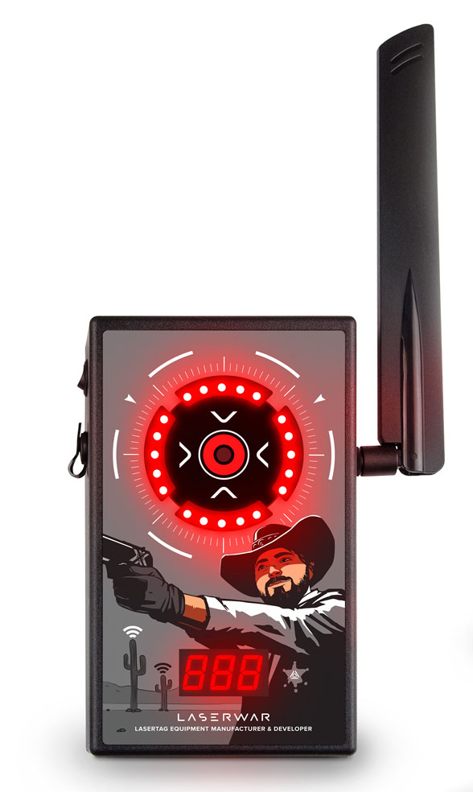

PRODUCT'S PASSPORT

Dear customer!
On the behalf of OOO "Lasertag" company we are happy to welcome you and thank you for choosing our products, we are confident that the product which you have purchased from us will please you and last for a long time. This warranty card establishes a warranty liability for the product to the extent provided by the Law of the Russian Federation "On the Protection of Consumer Rights".
This warranty card is valid for 12 months from the date of purchase of the product, subject to the compliance of the terms of the warranty.
Warranty terms:
1. The warranty becomes effective upon presentation of this warranty card where the serial number of the product and the date of its purchase confirmed by the service center shall be indicated.
2. These warranty obligations apply to products purchased only from an official representative of OOO "Lasertag" company or its Official Dealer.
3. This warranty is not valid if the faults in the product have been caused by:
- failure to follow the Instructions for use;
- mechanical damage;
- entry of foreign objects, liquids, etc. into the product;
- animal activities;
- unauthorized access to the units and parts of the product by persons not authorized to perform these actions;
- use of the product for purposes other than those it has been designed for;
- force majeure (natural disaster, fire, accident, etc.);
- the product's breakdown due to improper connection, faulty power supply and/or poor care of the product.
4. In case an original warranty card is lost, a duplicate can not be issued.

10. Contact information

Official website:
www.laserwar.com

E-mail: Date of purchase: _________________________
info@laserwar.com
help@laserwar.com

Skype:
info@laserwar.com
help@laserwar.com

______________________________________
signature

2
7
Information on repairs performed during the warranty period (to be filled out by workers of the service centre where the warranty repair service is provided).

Date:__________________  Performed works: _____________________________________________________________________  Service centre's stamp | Date:__________________  Performed works: _____________________________________________________________________  Service centre's stamp
Date:__________________  Performed works: _____________________________________________________________________  Service centre's stamp | Date:__________________  Performed works: _____________________________________________________________________  Service centre's stamp
Date:__________________  Performed works: _____________________________________________________________________  Service centre's stamp | Date:__________________  Performed works: _____________________________________________________________________  Service centre's stamp

1. Description
"Wild West target" is a gaming device that is an integral part of the "Wild West shooting range" arcade attraction and it can be used for increasing the number of the shooting range targets when game events are organized at home, in a club, in a shopping mall, or nature.

2. Application
The device is designed for organizing an interactive attraction under the control of computer software and can be used for organizing sports events, tactic training, and corporate and entertainment events.

3. Package set
- Electronic target - 1 piece.
- Product's passport - 1 piece.

4. Basic technical specifications
Dimensions of the target, mm | 185х115х65
Charger | Smart li+ or Spider charger
Number of defeat sensors of the target, pieces | 1
Number of LEDs of the RGB target, pieces | 20
Battery capacity, A/h | 2.2
Weight, kg | 0.9
Battery type | lithium

5. Design
A target for the "Wild West shooting range" is made of a plastic body that contains installed electronics, indicator elements and a radio antenna, as well as a battery and a charging outlet.

3
6
Rules for operating the equipment
1. Weather conditions During the production process, the equipment is tested for performance under various weather conditions. Despite this, we strongly recommend not to use the equipment in rainy weather and at temperatures below -20°C.
What do you need to know when operating game sets in unfavorable weather conditions?
The most important thing is not to allow moisture to enter inside the device. If this has happened, stop operating the device and dry the equipment at room temperature for at least 2 hours.

2. Power supply. The "Electronic target RGB" game set is equipped with lithium batteries as a power supply.

The device must be stored in a well-ventilated room at a temperature from +18°С to +30 °С and with relative air humidity of 45-65%.
The warranty period for batteries, speakers and IR modules is 14 DAYS. These accessories are consumables.

ATTENTION! The warranty shall not cover the batteries in case of their improper use (charging them with an inappropriate type of a charger)!

Computer software is installed on the controlling PC, the radio base is connected to it via a USB port, targets are operated independently.

6. Maintenance
It's important to take good care of all parts of the game set so that the equipment can function properly. Don't let the entry of liquids inside the case. Charge the battery timely. The game set is charged by a charger (a charger is not included in the game set and must be purchased separately). Avoid hitting the device.

7. Instructions for use
An electronic target is activated by a switch which is located on the top end of the device. After activation, battery power is shown on the display located at the bottom. After the targets are activated, they come under computer software control. It's necessary to activate one of the seven scenarios offered by the program.

8. Changing combat characteristics of the game set
"Electronic target RGB"

The settings are changed with the use of the software. The detailed instruction manual can be downloaded from laserwar.ru

9. Warranties
The manufacturer guarantees operational reliability of the "LASERWAR" individual game set if the customer observes the rules of the correct operation. The warranty period for technical support is 12 months starting from the date of the purchase. The manufacturer undertakes to replace or repair the equipment of an individual game set free of charge, subject to the customer's observance of transportation, storage and operation rules and paid delivery of faulty equipment to Smolensk.

4
5

